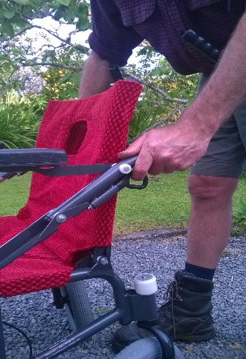
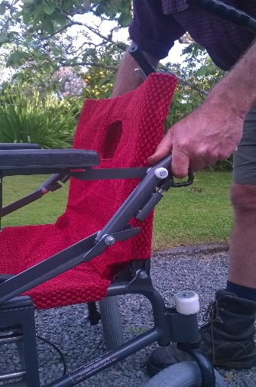
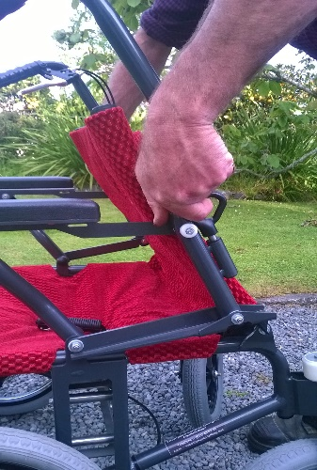
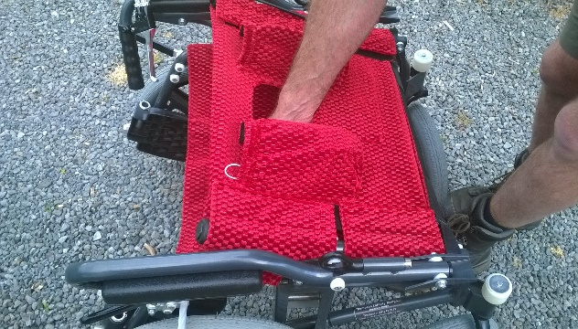
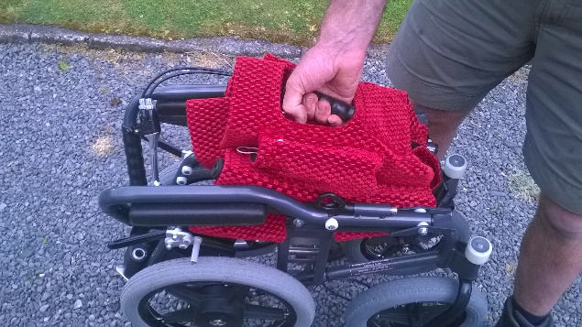

Push handle through backrest and then separate the two seat handles as if you were opening a book. Best control from centre of handles
Pull seat handles up towards yourself until they lock into place with locking pins on either side. Push down on seat handle to flatten seat. Fold out footrests to finish.
To fold up repeat instructions in reverse. Start by pulling locking pins out under each handle.

Safety Considerations
Keep hands away from moving parts while chair is moving.
Seat belt is provided for further user safety during use.
Both driver brakes and seated brakes can be used to stop chair.
Chair is still manual and will need able bodied person to push for duration of journey.
Enjoy!

